**UNIVERSIDAD DE PUERTO RICO**

**RECINTO UNIVERSITARIO DE MAYAGUEZ**

**FACULTAD DE INGENIERIA**

**DEPARTAMENTO DE INGENIERIA**

Prof. Rodriguez

ICOM4215-

Hector Hernandez

Pedro Colon

Marie Nazario

Computer Architecture

Report

Contents

ASMD Diagram 2

Data Path & Register File Block Diagrams 3

Data Path 3

Register File 4

Control Unit Block Diagram 5

Data path Circuit Diagram 6

Microprogram 7

Code & Simulation 9

Code 9

Simulation 10

# ASMD Diagram

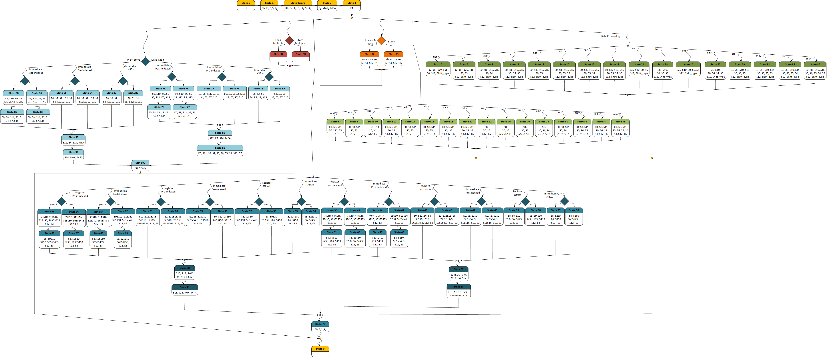

# Data Path & Register File Block Diagrams

## Data Path

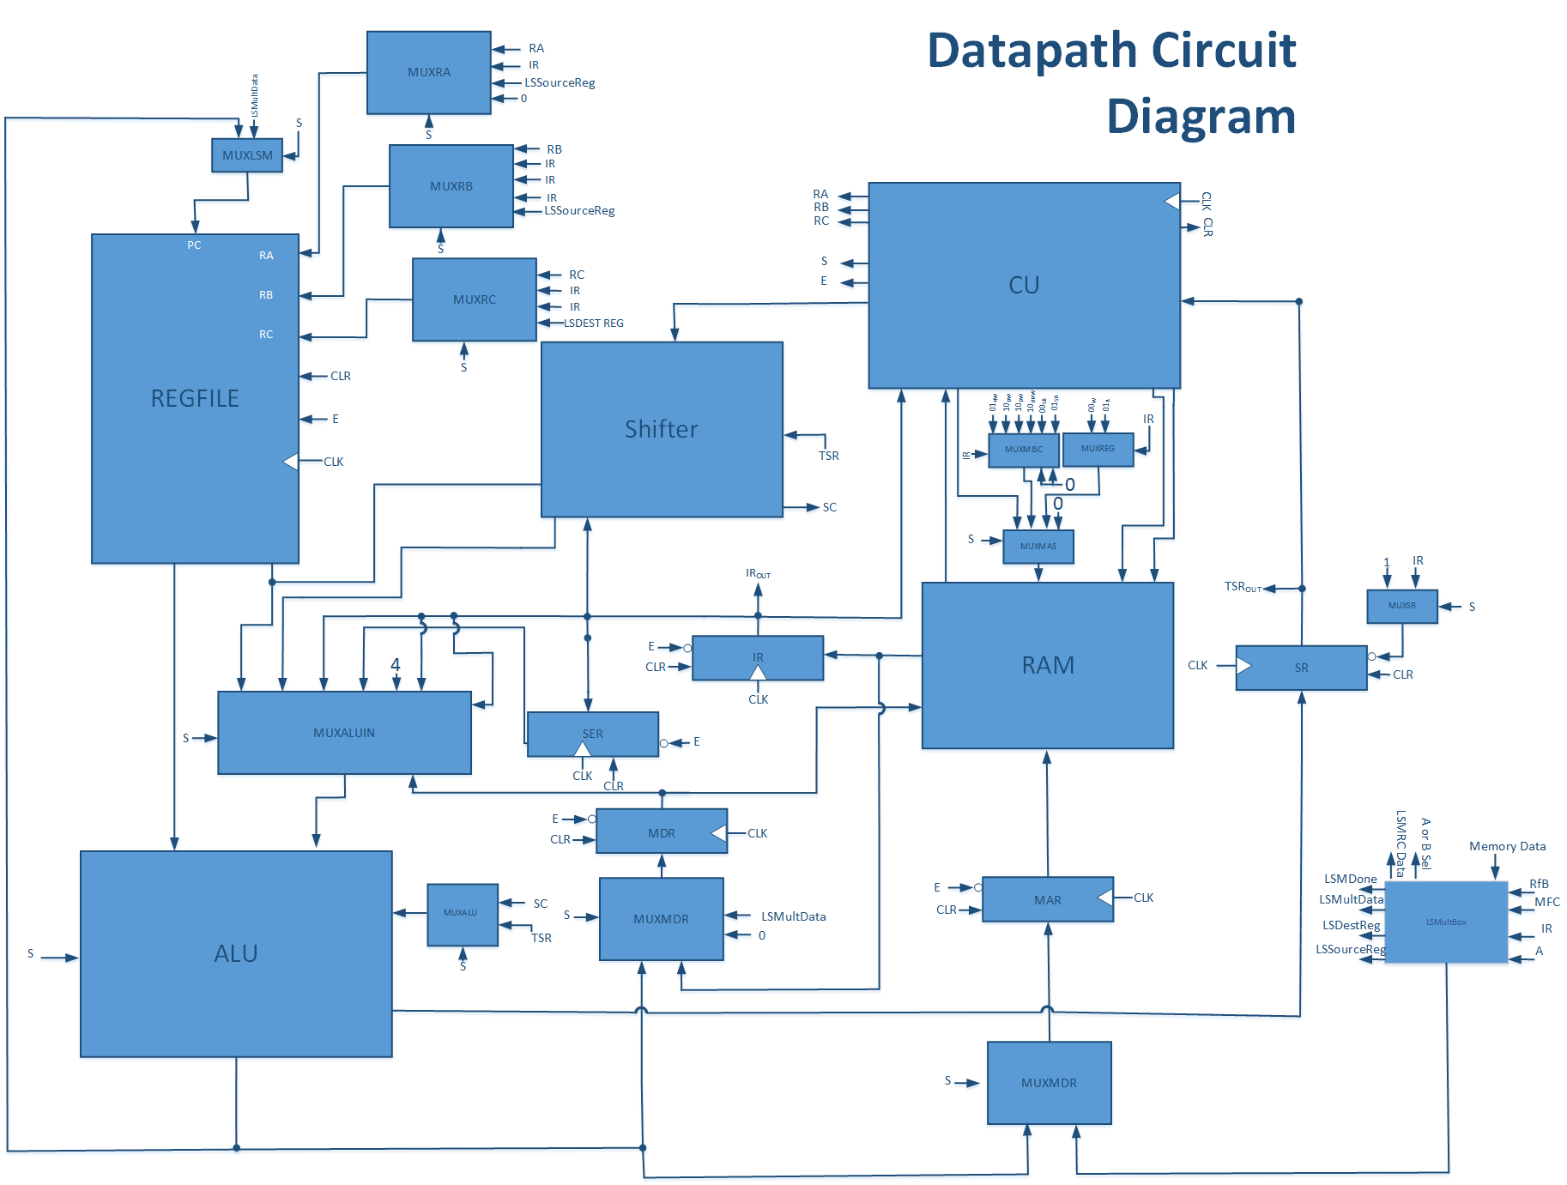

## Register File

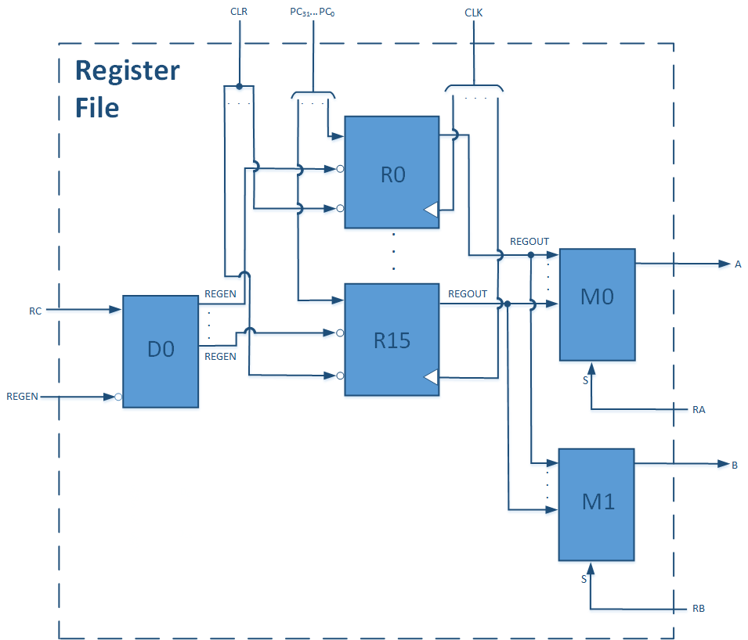

# Control Unit Block Diagram

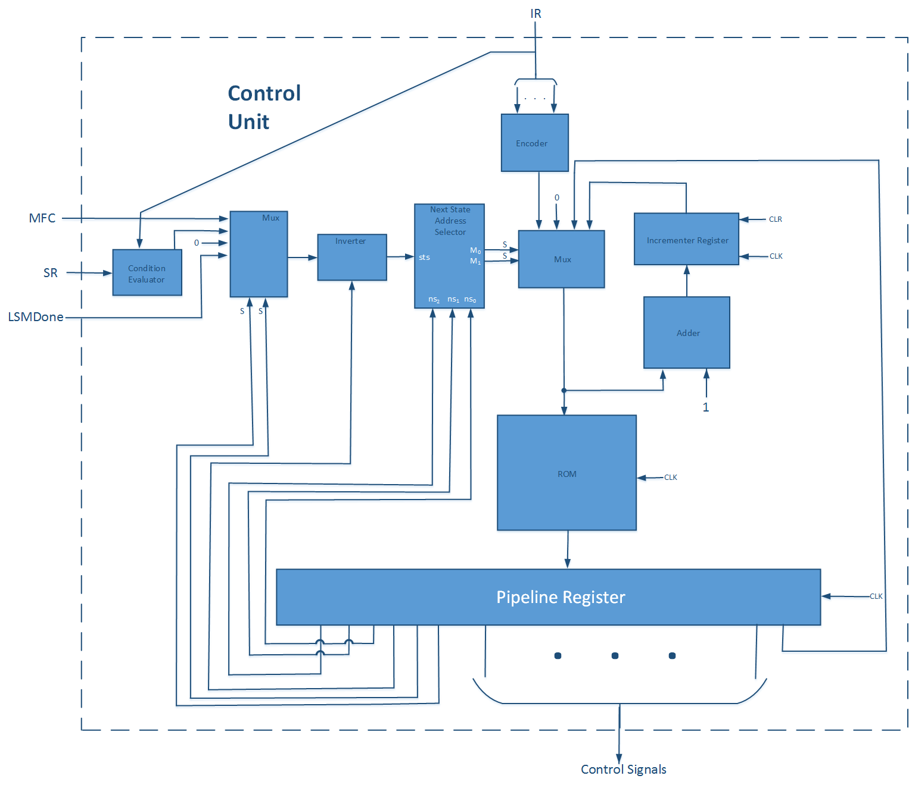

# Data path Circuit Diagram

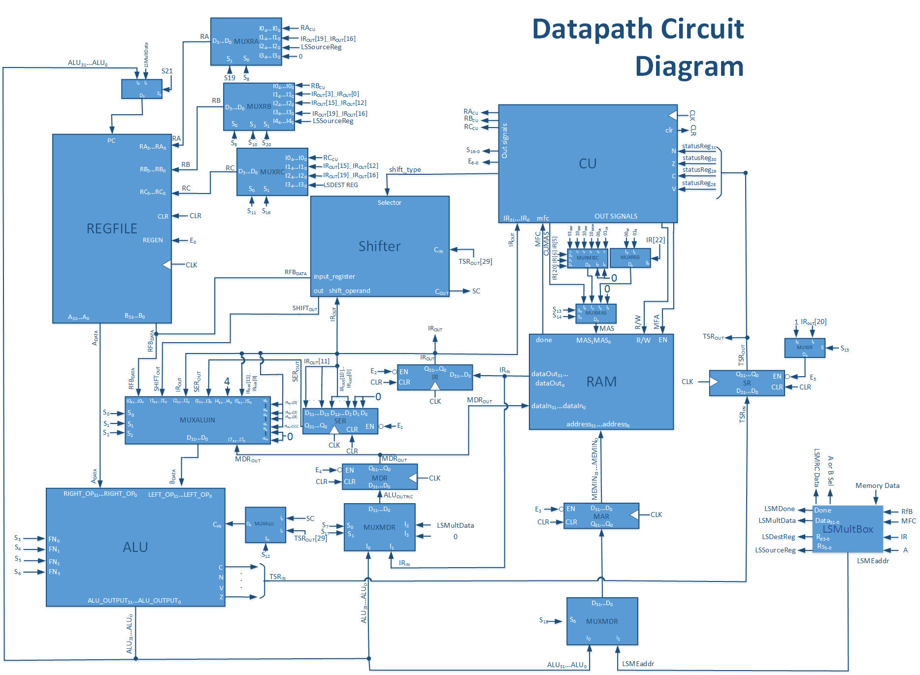

# Microprogram

mem[0][58:0]= 59'b000000000110000000101ZZZZ0ZZZZ00ZZZZ00000000000111100000010;

mem[1][58:0] = 59'b000000000110000000111ZZZZ0111100ZZZZ00000110100110100000010;

mem[2][58:0] = 59'b00000000011000000011011110ZZZZ00111100100010000111100000010;

mem[3][58:0]= 59'b000000001011000001110ZZZZ0ZZZZ00ZZZZ00000000000101100001011;

mem[4][58:0] = 59'b00000001100100000011100000000000ZZZZ00000000000011100000010;

mem[6][58:0] = 59'b00000001010110111001000001000000ZZZZ01001000010111101000010;

mem[5][58:0] = 59'b00000001010110111001000001000001ZZZZ01001000011111101000010;

mem[8][58:0] = 59'b00000001010110111001000001000000000001001000110111101000010;

mem[7][58:0] = 59'b00000001010110111001000001000001000001001000111111101000010;

mem[10][58:0] = 59'b00000001010110111001000001000000000001001001010111101000010;

mem[9][58:0] = 59'b00000001010110111001000001000001000001001001011111101000010;

mem[12][58:0] = 59'b00000001010110111001000001000000000001001001110111101000010;

mem[11][58:0] = 59'b00000001010110111001000001000001000001001001111111101000010;

mem[14][58:0] = 59'b00000001010110111001000001000000000001001010010111101000010;

mem[13][58:0] = 59'b00000001010110111001000001000001000001001010011111101000010;

mem[16][58:0] = 59'b00000001010110111001000001000000000001001010110111101000010;

mem[15][58:0] = 59'b00000001010110111001000001000001000001001010111111101000010;

mem[18][58:0] = 59'b00000001010110111001000001000000000001001011010111101000010;

mem[17][58:0] = 59'b00000001010110111001000001000001000001001011011111101000010;

mem[20][58:0] = 59'b00000001010110111001000001000000000001001011110111101000010;

mem[19][58:0] = 59'b00000001010110111001000001000001000001001011111111101000010;

mem[22][58:0] = 59'b00000001010110111001100001000000000000001100010111101000010;

mem[21][58:0] = 59'b00000001010110111001100001000001000000001100011111101000010;

mem[24][58:0] = 59'b00000001010110111001100001000000000000001100110111101000010;

mem[23][58:0] = 59'b00000001010110111001100001000001000000001100111111101000010;

mem[26][58:0] = 59'b00000001010110111001100001000000000000001101010111101000010;

mem[25][58:0] = 59'b00000001010110111001100001000001000000001101011111101000010;

mem[28][58:0] = 59'b00000001010110111001100001000000000000001101110111101000010;

mem[27][58:0] = 59'b00000001010110111001100001000001000000001101111111101000010;

mem[30][58:0] = 59'b00000001010110111001000001000000000001001110010111101000010;

mem[29][58:0] = 59'b00000001010110111001000001000001000001001110011111101000010;

mem[32][58:0] = 59'b00000001010110111001000001000000000001001110110111101000010;

mem[31][58:0] = 59'b00000001010110111001000001000001000001001110111111101000010;

mem[34][58:0] = 59'b00000001100110111001000001000000000001001111010111101000010;

mem[33][58:0] = 59'b00000001010110111001000001000001000001001111011111101000010;

mem[36][58:0] = 59'b00000001010110111001000001000000000001001111110111101000010;

mem[35][58:0] = 59'b00000001010110111001000001000001000001001111111111101000010;

mem[96][58:0] = 59'b00000001010101101001100001000000000000101010010110100000010;

mem[37][58:0] = 59'b00000001010101101001100001000000000000101001010110100000010;

mem[38][58:0] = 59'b00000001010101101001100001000001000000000010010110100000010;

mem[39][58:0] = 59'b00000001010101101001100001000001000000000001010110100000010;

mem[40][58:0] = 59'b00000001010111000011000001000000000010101010010110100000010;

mem[41][58:0] = 59'b00000001010111000011000001000000000010101001010110100000010;

mem[42][58:0] = 59'b00000001010111000011000001000001000010000010010110100000010;

mem[43][58:0] = 59'b00000001010111000011000001000001000010000001010110100000010;

mem[44][58:0] = 59'b00000001011101011011100000000011000000000110110110100000010;

mem[46][58:0] = 59'b00000001011101011111100000000011000000000110110110100000010;

mem[45][58:0] = 59'b00000001010111000011000001000000000010101010010111100000010;

mem[47][58:0] = 59'b00000001010111000011000001000000000010101001010111100000010;

mem[48][58:0] = 59'b00000001011101100011100000000011000000000110110110100000010;

mem[50][58:0] = 59'b00000001011101100111100000000011000000000110110110100000010;

mem[49][58:0] = 59'b00000001010111000011000001000001000010000010010111100000010;

mem[51][58:0] = 59'b00000001011111000011000001000001000010000001010111100000010;

mem[97][58:0]=59'b000000010101011010010ZZZZXZZZZXXZZZZXX000110111111110000010;

mem[52][58:0] = 59'b00000000101101101001100000000000000000111110110111010100011;

mem[53][58:0] = 59'b00000001010110010001000000000000000001111110111111110000010;

mem[54][58:0] = 59'b00000001010110001101100001000000000000101010010110100000010;

mem[55][58:0] = 59'b00000001010110001101100001000000000000101001010110100000010;

mem[56][58:0] = 59'b00000001010110001101100001000001000000000010010110100000010;

mem[57][58:0] = 59'b00000001010110001101100001000001000000000001010110100000010;

mem[58][58:0] = 59'b00000001010111000101000001000000000010101010010110100000010;

mem[59][58:0] = 59'b00000001010111000101000001000000000010101001010110100000010;

mem[60][58:0] = 59'b00000001010111000101000001000001000010000010010110100000010;

mem[61][58:0] = 59'b00000001010111000101000001000001000010000001010110100000010;

mem[62][58:0] = 59'b00000001011101111111100000000011000000000110110110100000010;

mem[64][58:0] = 59'b00000001011110000011100000000011000000000110110110100000010;

mem[63][58:0] = 59'b00000001010111000101000001000000000010101010010111100000010;

mem[65][58:0] = 59'b00000001010111000101000001000000000010101001010111100000010;

mem[66][58:0] = 59'b00000001011110000111100000000011000000000110110110100000010;

mem[68][58:0] = 59'b00000001011110001011100000000011000000000110110110100000010;

mem[67][58:0] = 59'b00000001010111000101000001000001000010000010010111100000010;

mem[69][58:0] = 59'b00000001011111000101000001000001000010000001010111100000010;

mem[98][58:0] = 59'b000000010101100011010ZZZZXZZZZXXZZZZXX000110111111110000010;

mem[70][58:0] = 59'b00000001011110001111100000000010000000000110110111000100011;

mem[71][58:0] = 59'b00000000101110001111100000000000000000000110110111100100001;

mem[72][58:0] = 59'b000000010101000000110ZZZZXZZZZXXZZZZXX000110111111110000010;

mem[95][58:0] = 59'b00000001010110100001100001000000000000110010010110111000010;

mem[73][58:0] = 59'b00000001010111000111100001000000000000110001010110111000010;

mem[74][58:0] = 59'b00000001010110100001000001000000000010110010010110111000010;

mem[75][58:0] = 59'b00000001010111000111000001000000000010110001010110111000010;

mem[76][58:0] = 59'b00000001011110011011100000000011000000000110110110101000010;

mem[78][58:0] = 59'b00000001011110011111100000000011000000000110110110101000010;

mem[77][58:0] = 59'b00000001010111000111000001000000000010110010000111111000010;

mem[79][58:0] = 59'b00000001011111000111000001000000000010110001000111111000010;

mem[99][58:0] = 59'b000000010101101000010ZZZZXZZZZXXZZZZXX000110111111110000010;

mem[80][58:0] = 59'b00000000101110100001100000000000000000000110110111010010011;

mem[81][58:0] = 59'b00000001010110111001000000000000000001111110110111010010010;

mem[82][58:0] = 59'b00000001010110110101100001000000000000110010000110111000010;

mem[83][58:0] = 59'b00000001010110110101100001000000000000110001000110111000010;

mem[84][58:0] = 59'b00000001010111001001000001000000000010110010000110111000010;

mem[85][58:0] = 59'b00000001010111001001000001000000000010110001000110111000010;

mem[86][58:0] = 59'b00000001011110101111100000000011000000000110110110101000010;

mem[88][58:0] = 59'b00000001011110110011100000000011000000000110110110101000010;

mem[87][58:0] = 59'b00000001010111001001000001000000000010110010000111111000010;

mem[89][58:0] = 59'b00000001011111001001000001000000000010110001000111111000010;

mem[100][58:0]=59'b000000010101101101010ZZZZXZZZZXXZZZZXX000110111111110000010;

mem[90][58:0] = 59'b00000001011110110111100000000010000000000110100111000010001;

mem[91][58:0] = 59'b00000000101110110111100000000000000000000110110111100010011;

mem[92][58:0]=59'b000000010101000000110ZZZZXZZZZXXZZZZXX000110111111110000010;

mem[93][58:0] = 59'b00000000011110111101000000111100111000000110110000000000010;

mem[94][58:0] = 59'b00000000010110111001011110000000111100011010010100000000010;

mem[101][58:0]=59'b111111111011110010110ZZZZ0ZZZZ00ZZZZ11111110110110000001011;

mem[102][58:0]=59'b111111110101000000110ZZZZXZZZZXXZZZZXX111110110111110001010;

mem[105][58:0]=59'b111111110101110011110ZZZZ0ZZZZ00ZZZZ11000110110110000001000;

mem[103][58:0]=59'b111111111011110011110ZZZZ0ZZZZ00ZZZZ11000110110110000001001;

mem[104][58:0]=59’b111111110101000000110ZZZZXZZZZXXZZZZXX000110110111110001000;

# Code & Simulation

## Code

## Simulation